https://www.w3schools.com/colors/default.asp:
Colors Tutorial (w3schools.com)

Colors HOME

Color Names
With CSS, colors can be set by using color names:

Example
Color | Name
 | Red
 | Yellow
 | Cyan
 | Blue
 | Magenta


CSS Color Values
With CSS, colors can be specified in different ways:
- By color names
- As RGB values
- As hexadecimal values
- As HSL values (CSS3)
- As HWB values (CSS4)

RGB Colors
RGB color values are supported in all browsers.
An RGB color value is specified with: rgb(red, green, blue).
Each parameter (red, green, and blue) defines the intensity of the color as an integer between 0 and 255.
For example, rgb(0,0,255) is rendered as blue, because the blue parameter is set to its highest value (255) and the others are set to 0.

Example
Color | RGB | Color
 | rgb(255,0,0) | Red
 | rgb(0,255,0) | Green
 | rgb(0,0,255) | Blue
Shades of gray are often defined using equal values for all the 3 light sources:

Example
Color | RGB | Color
 | rgb(0,0,0) | Black
 | rgb(128,128,128) | Gray
 | rgb(255,255,255) | White

Hexadecimal Colors
Hexadecimal color values are also supported in all browsers.
A hexadecimal color is specified with: #RRGGBB.
RR (red), GG (green) and BB (blue) are hexadecimal integers between 00 and FF specifying the intensity of the color.
For example, #0000FF is displayed as blue, because the blue component is set to its highest value (FF) and the others are set to 00.

Example
Color | HEX | RGB | Color
 | #FF0000 | rgb(255,0,0) | Red
 | #00FF00 | rgb(0,255,0) | Green
 | #0000FF | rgb(0,0,255) | Blue
Shades of gray are often defined using equal values for all the 3 light sources:

Example
Color | HEX | RGB | Color
 | #000000 | rgb(0,0,0) | Black
 | #808080 | rgb(128,128,128) | Gray
 | #FFFFFF | rgb(255,255,255) | White

Upper Case or Lower Case?
You can use upper case or lower case letters to specify hexadecimal values.
Lower case are easier to write. Upper case are easier to read.

Color Names
CSS supports 140 standard color names.
In the next chapter you will find a complete alphabetical list of color names with hexadecimal values:
Color Name | Hex | Color
AliceBlue | #F0F8FF
AntiqueWhite | #FAEBD7
Aqua | #00FFFF
Aquamarine | #7FFFD4
Azure | #F0FFFF
Beige | #F5F5DC
Bisque | #FFE4C4

Color Names

Color Names Supported by All Browsers
All modern browsers support the following 140 color names (click on a color name, or a hex value, to view the color as the background-color along with different text colors):
Click here to see the 140 colors sorted by HEX Value
Color Name | HEX | Color | Shades | Mix
AliceBlue | #F0F8FF |  | Shades | Mix
AntiqueWhite | #FAEBD7 |  | Shades | Mix
Aqua | #00FFFF |  | Shades | Mix
Aquamarine | #7FFFD4 |  | Shades | Mix
Azure | #F0FFFF |  | Shades | Mix
Beige | #F5F5DC |  | Shades | Mix
Bisque | #FFE4C4 |  | Shades | Mix
Black | #000000 |  | Shades | Mix
BlanchedAlmond | #FFEBCD |  | Shades | Mix
Blue | #0000FF |  | Shades | Mix
BlueViolet | #8A2BE2 |  | Shades | Mix
Brown | #A52A2A |  | Shades | Mix
BurlyWood | #DEB887 |  | Shades | Mix
CadetBlue | #5F9EA0 |  | Shades | Mix
Chartreuse | #7FFF00 |  | Shades | Mix
Chocolate | #D2691E |  | Shades | Mix
Coral | #FF7F50 |  | Shades | Mix
CornflowerBlue | #6495ED |  | Shades | Mix
Cornsilk | #FFF8DC |  | Shades | Mix
Crimson | #DC143C |  | Shades | Mix
Cyan | #00FFFF |  | Shades | Mix
DarkBlue | #00008B |  | Shades | Mix
DarkCyan | #008B8B |  | Shades | Mix
DarkGoldenRod | #B8860B |  | Shades | Mix
DarkGray | #A9A9A9 |  | Shades | Mix
DarkGrey | #A9A9A9 |  | Shades | Mix
DarkGreen | #006400 |  | Shades | Mix
DarkKhaki | #BDB76B |  | Shades | Mix
DarkMagenta | #8B008B |  | Shades | Mix
DarkOliveGreen | #556B2F |  | Shades | Mix
DarkOrange | #FF8C00 |  | Shades | Mix
DarkOrchid | #9932CC |  | Shades | Mix
DarkRed | #8B0000 |  | Shades | Mix
DarkSalmon | #E9967A |  | Shades | Mix
DarkSeaGreen | #8FBC8F |  | Shades | Mix
DarkSlateBlue | #483D8B |  | Shades | Mix
DarkSlateGray | #2F4F4F |  | Shades | Mix
DarkSlateGrey | #2F4F4F |  | Shades | Mix
DarkTurquoise | #00CED1 |  | Shades | Mix
DarkViolet | #9400D3 |  | Shades | Mix
DeepPink | #FF1493 |  | Shades | Mix
DeepSkyBlue | #00BFFF |  | Shades | Mix
DimGray | #696969 |  | Shades | Mix
DimGrey | #696969 |  | Shades | Mix
DodgerBlue | #1E90FF |  | Shades | Mix
FireBrick | #B22222 |  | Shades | Mix
FloralWhite | #FFFAF0 |  | Shades | Mix
ForestGreen | #228B22 |  | Shades | Mix
Fuchsia | #FF00FF |  | Shades | Mix
Gainsboro | #DCDCDC |  | Shades | Mix
GhostWhite | #F8F8FF |  | Shades | Mix
Gold | #FFD700 |  | Shades | Mix
GoldenRod | #DAA520 |  | Shades | Mix
Gray | #808080 |  | Shades | Mix
Grey | #808080 |  | Shades | Mix
Green | #008000 |  | Shades | Mix
GreenYellow | #ADFF2F |  | Shades | Mix
HoneyDew | #F0FFF0 |  | Shades | Mix
HotPink | #FF69B4 |  | Shades | Mix
IndianRed | #CD5C5C |  | Shades | Mix
Indigo | #4B0082 |  | Shades | Mix
Ivory | #FFFFF0 |  | Shades | Mix
Khaki | #F0E68C |  | Shades | Mix
Lavender | #E6E6FA |  | Shades | Mix
LavenderBlush | #FFF0F5 |  | Shades | Mix
LawnGreen | #7CFC00 |  | Shades | Mix
LemonChiffon | #FFFACD |  | Shades | Mix
LightBlue | #ADD8E6 |  | Shades | Mix
LightCoral | #F08080 |  | Shades | Mix
LightCyan | #E0FFFF |  | Shades | Mix
LightGoldenRodYellow | #FAFAD2 |  | Shades | Mix
LightGray | #D3D3D3 |  | Shades | Mix
LightGrey | #D3D3D3 |  | Shades | Mix
LightGreen | #90EE90 |  | Shades | Mix
LightPink | #FFB6C1 |  | Shades | Mix
LightSalmon | #FFA07A |  | Shades | Mix
LightSeaGreen | #20B2AA |  | Shades | Mix
LightSkyBlue | #87CEFA |  | Shades | Mix
LightSlateGray | #778899 |  | Shades | Mix
LightSlateGrey | #778899 |  | Shades | Mix
LightSteelBlue | #B0C4DE |  | Shades | Mix
LightYellow | #FFFFE0 |  | Shades | Mix
Lime | #00FF00 |  | Shades | Mix
LimeGreen | #32CD32 |  | Shades | Mix
Linen | #FAF0E6 |  | Shades | Mix
Magenta | #FF00FF |  | Shades | Mix
Maroon | #800000 |  | Shades | Mix
MediumAquaMarine | #66CDAA |  | Shades | Mix
MediumBlue | #0000CD |  | Shades | Mix
MediumOrchid | #BA55D3 |  | Shades | Mix
MediumPurple | #9370DB |  | Shades | Mix
MediumSeaGreen | #3CB371 |  | Shades | Mix
MediumSlateBlue | #7B68EE |  | Shades | Mix
MediumSpringGreen | #00FA9A |  | Shades | Mix
MediumTurquoise | #48D1CC |  | Shades | Mix
MediumVioletRed | #C71585 |  | Shades | Mix
MidnightBlue | #191970 |  | Shades | Mix
MintCream | #F5FFFA |  | Shades | Mix
MistyRose | #FFE4E1 |  | Shades | Mix
Moccasin | #FFE4B5 |  | Shades | Mix
NavajoWhite | #FFDEAD |  | Shades | Mix
Navy | #000080 |  | Shades | Mix
OldLace | #FDF5E6 |  | Shades | Mix
Olive | #808000 |  | Shades | Mix
OliveDrab | #6B8E23 |  | Shades | Mix
Orange | #FFA500 |  | Shades | Mix
OrangeRed | #FF4500 |  | Shades | Mix
Orchid | #DA70D6 |  | Shades | Mix
PaleGoldenRod | #EEE8AA |  | Shades | Mix
PaleGreen | #98FB98 |  | Shades | Mix
PaleTurquoise | #AFEEEE |  | Shades | Mix
PaleVioletRed | #DB7093 |  | Shades | Mix
PapayaWhip | #FFEFD5 |  | Shades | Mix
PeachPuff | #FFDAB9 |  | Shades | Mix
Peru | #CD853F |  | Shades | Mix
Pink | #FFC0CB |  | Shades | Mix
Plum | #DDA0DD |  | Shades | Mix
PowderBlue | #B0E0E6 |  | Shades | Mix
Purple | #800080 |  | Shades | Mix
RebeccaPurple | #663399 |  | Shades | Mix
Red | #FF0000 |  | Shades | Mix
RosyBrown | #BC8F8F |  | Shades | Mix
RoyalBlue | #4169E1 |  | Shades | Mix
SaddleBrown | #8B4513 |  | Shades | Mix
Salmon | #FA8072 |  | Shades | Mix
SandyBrown | #F4A460 |  | Shades | Mix
SeaGreen | #2E8B57 |  | Shades | Mix
SeaShell | #FFF5EE |  | Shades | Mix
Sienna | #A0522D |  | Shades | Mix
Silver | #C0C0C0 |  | Shades | Mix
SkyBlue | #87CEEB |  | Shades | Mix
SlateBlue | #6A5ACD |  | Shades | Mix
SlateGray | #708090 |  | Shades | Mix
SlateGrey | #708090 |  | Shades | Mix
Snow | #FFFAFA |  | Shades | Mix
SpringGreen | #00FF7F |  | Shades | Mix
SteelBlue | #4682B4 |  | Shades | Mix
Tan | #D2B48C |  | Shades | Mix
Teal | #008080 |  | Shades | Mix
Thistle | #D8BFD8 |  | Shades | Mix
Tomato | #FF6347 |  | Shades | Mix
Turquoise | #40E0D0 |  | Shades | Mix
Violet | #EE82EE |  | Shades | Mix
Wheat | #F5DEB3 |  | Shades | Mix
White | #FFFFFF |  | Shades | Mix
WhiteSmoke | #F5F5F5 |  | Shades | Mix
Yellow | #FFFF00 |  | Shades | Mix
YellowGreen | #9ACD32 |  | Shades | Mix

HTML Color Values

Named Colors Sorted by HEX Value
Click here to see the colors sorted by name
Color Name | HEX | Color | Shades | Mix
Black | #000000 |  | Shades | Mix
Navy | #000080 |  | Shades | Mix
DarkBlue | #00008B |  | Shades | Mix
MediumBlue | #0000CD |  | Shades | Mix
Blue | #0000FF |  | Shades | Mix
DarkGreen | #006400 |  | Shades | Mix
Green | #008000 |  | Shades | Mix
Teal | #008080 |  | Shades | Mix
DarkCyan | #008B8B |  | Shades | Mix
DeepSkyBlue | #00BFFF |  | Shades | Mix
DarkTurquoise | #00CED1 |  | Shades | Mix
MediumSpringGreen | #00FA9A |  | Shades | Mix
Lime | #00FF00 |  | Shades | Mix
SpringGreen | #00FF7F |  | Shades | Mix
Aqua | #00FFFF |  | Shades | Mix
Cyan | #00FFFF |  | Shades | Mix
MidnightBlue | #191970 |  | Shades | Mix
DodgerBlue | #1E90FF |  | Shades | Mix
LightSeaGreen | #20B2AA |  | Shades | Mix
ForestGreen | #228B22 |  | Shades | Mix
SeaGreen | #2E8B57 |  | Shades | Mix
DarkSlateGray | #2F4F4F |  | Shades | Mix
DarkSlateGrey | #2F4F4F |  | Shades | Mix
LimeGreen | #32CD32 |  | Shades | Mix
MediumSeaGreen | #3CB371 |  | Shades | Mix
Turquoise | #40E0D0 |  | Shades | Mix
RoyalBlue | #4169E1 |  | Shades | Mix
SteelBlue | #4682B4 |  | Shades | Mix
DarkSlateBlue | #483D8B |  | Shades | Mix
MediumTurquoise | #48D1CC |  | Shades | Mix
Indigo | #4B0082 |  | Shades | Mix
DarkOliveGreen | #556B2F |  | Shades | Mix
CadetBlue | #5F9EA0 |  | Shades | Mix
CornflowerBlue | #6495ED |  | Shades | Mix
RebeccaPurple | #663399 |  | Shades | Mix
MediumAquaMarine | #66CDAA |  | Shades | Mix
DimGray | #696969 |  | Shades | Mix
DimGrey | #696969 |  | Shades | Mix
SlateBlue | #6A5ACD |  | Shades | Mix
OliveDrab | #6B8E23 |  | Shades | Mix
SlateGray | #708090 |  | Shades | Mix
SlateGrey | #708090 |  | Shades | Mix
LightSlateGray | #778899 |  | Shades | Mix
LightSlateGrey | #778899 |  | Shades | Mix
MediumSlateBlue | #7B68EE |  | Shades | Mix
LawnGreen | #7CFC00 |  | Shades | Mix
Chartreuse | #7FFF00 |  | Shades | Mix
Aquamarine | #7FFFD4 |  | Shades | Mix
Maroon | #800000 |  | Shades | Mix
Purple | #800080 |  | Shades | Mix
Olive | #808000 |  | Shades | Mix
Gray | #808080 |  | Shades | Mix
Grey | #808080 |  | Shades | Mix
SkyBlue | #87CEEB |  | Shades | Mix
LightSkyBlue | #87CEFA |  | Shades | Mix
BlueViolet | #8A2BE2 |  | Shades | Mix
DarkRed | #8B0000 |  | Shades | Mix
DarkMagenta | #8B008B |  | Shades | Mix
SaddleBrown | #8B4513 |  | Shades | Mix
DarkSeaGreen | #8FBC8F |  | Shades | Mix
LightGreen | #90EE90 |  | Shades | Mix
MediumPurple | #9370DB |  | Shades | Mix
DarkViolet | #9400D3 |  | Shades | Mix
PaleGreen | #98FB98 |  | Shades | Mix
DarkOrchid | #9932CC |  | Shades | Mix
YellowGreen | #9ACD32 |  | Shades | Mix
Sienna | #A0522D |  | Shades | Mix
Brown | #A52A2A |  | Shades | Mix
DarkGray | #A9A9A9 |  | Shades | Mix
DarkGrey | #A9A9A9 |  | Shades | Mix
LightBlue | #ADD8E6 |  | Shades | Mix
GreenYellow | #ADFF2F |  | Shades | Mix
PaleTurquoise | #AFEEEE |  | Shades | Mix
LightSteelBlue | #B0C4DE |  | Shades | Mix
PowderBlue | #B0E0E6 |  | Shades | Mix
FireBrick | #B22222 |  | Shades | Mix
DarkGoldenRod | #B8860B |  | Shades | Mix
MediumOrchid | #BA55D3 |  | Shades | Mix
RosyBrown | #BC8F8F |  | Shades | Mix
DarkKhaki | #BDB76B |  | Shades | Mix
Silver | #C0C0C0 |  | Shades | Mix
MediumVioletRed | #C71585 |  | Shades | Mix
IndianRed | #CD5C5C |  | Shades | Mix
Peru | #CD853F |  | Shades | Mix
Chocolate | #D2691E |  | Shades | Mix
Tan | #D2B48C |  | Shades | Mix
LightGray | #D3D3D3 |  | Shades | Mix
LightGrey | #D3D3D3 |  | Shades | Mix
Thistle | #D8BFD8 |  | Shades | Mix
Orchid | #DA70D6 |  | Shades | Mix
GoldenRod | #DAA520 |  | Shades | Mix
PaleVioletRed | #DB7093 |  | Shades | Mix
Crimson | #DC143C |  | Shades | Mix
Gainsboro | #DCDCDC |  | Shades | Mix
Plum | #DDA0DD |  | Shades | Mix
BurlyWood | #DEB887 |  | Shades | Mix
LightCyan | #E0FFFF |  | Shades | Mix
Lavender | #E6E6FA |  | Shades | Mix
DarkSalmon | #E9967A |  | Shades | Mix
Violet | #EE82EE |  | Shades | Mix
PaleGoldenRod | #EEE8AA |  | Shades | Mix
LightCoral | #F08080 |  | Shades | Mix
Khaki | #F0E68C |  | Shades | Mix
AliceBlue | #F0F8FF |  | Shades | Mix
HoneyDew | #F0FFF0 |  | Shades | Mix
Azure | #F0FFFF |  | Shades | Mix
SandyBrown | #F4A460 |  | Shades | Mix
Wheat | #F5DEB3 |  | Shades | Mix
Beige | #F5F5DC |  | Shades | Mix
WhiteSmoke | #F5F5F5 |  | Shades | Mix
MintCream | #F5FFFA |  | Shades | Mix
GhostWhite | #F8F8FF |  | Shades | Mix
Salmon | #FA8072 |  | Shades | Mix
AntiqueWhite | #FAEBD7 |  | Shades | Mix
Linen | #FAF0E6 |  | Shades | Mix
LightGoldenRodYellow | #FAFAD2 |  | Shades | Mix
OldLace | #FDF5E6 |  | Shades | Mix
Red | #FF0000 |  | Shades | Mix
Fuchsia | #FF00FF |  | Shades | Mix
Magenta | #FF00FF |  | Shades | Mix
DeepPink | #FF1493 |  | Shades | Mix
OrangeRed | #FF4500 |  | Shades | Mix
Tomato | #FF6347 |  | Shades | Mix
HotPink | #FF69B4 |  | Shades | Mix
Coral | #FF7F50 |  | Shades | Mix
DarkOrange | #FF8C00 |  | Shades | Mix
LightSalmon | #FFA07A |  | Shades | Mix
Orange | #FFA500 |  | Shades | Mix
LightPink | #FFB6C1 |  | Shades | Mix
Pink | #FFC0CB |  | Shades | Mix
Gold | #FFD700 |  | Shades | Mix
PeachPuff | #FFDAB9 |  | Shades | Mix
NavajoWhite | #FFDEAD |  | Shades | Mix
Moccasin | #FFE4B5 |  | Shades | Mix
Bisque | #FFE4C4 |  | Shades | Mix
MistyRose | #FFE4E1 |  | Shades | Mix
BlanchedAlmond | #FFEBCD |  | Shades | Mix
PapayaWhip | #FFEFD5 |  | Shades | Mix
LavenderBlush | #FFF0F5 |  | Shades | Mix
SeaShell | #FFF5EE |  | Shades | Mix
Cornsilk | #FFF8DC |  | Shades | Mix
LemonChiffon | #FFFACD |  | Shades | Mix
FloralWhite | #FFFAF0 |  | Shades | Mix
Snow | #FFFAFA |  | Shades | Mix
Yellow | #FFFF00 |  | Shades | Mix
LightYellow | #FFFFE0 |  | Shades | Mix
Ivory | #FFFFF0 |  | Shades | Mix
White | #FFFFFF |  | Shades | Mix

HTML Color Groups
Color Names Sorted by Color Groups
All modern browsers support the following 140 color names (click on a color name, or a hex value, to view the color as the background-color along with different text colors):
Click here to see the 140 colors sorted by Name
Click here to see the 140 colors sorted by HEX Value

Pink Colors:
Color Name | HEX | Color | Shades | Mix
Pink | #FFC0CB |  | Shades | Mix
LightPink | #FFB6C1 |  | Shades | Mix
HotPink | #FF69B4 |  | Shades | Mix
DeepPink | #FF1493 |  | Shades | Mix
PaleVioletRed | #DB7093 |  | Shades | Mix
MediumVioletRed | #C71585 |  | Shades | Mix

Purple Colors:
Color Name | HEX | Color | Shades | Mix
Lavender | #E6E6FA |  | Shades | Mix
Thistle | #D8BFD8 |  | Shades | Mix
Plum | #DDA0DD |  | Shades | Mix
Orchid | #DA70D6 |  | Shades | Mix
Violet | #EE82EE |  | Shades | Mix
Fuchsia | #FF00FF |  | Shades | Mix
Magenta | #FF00FF |  | Shades | Mix
MediumOrchid | #BA55D3 |  | Shades | Mix
DarkOrchid | #9932CC |  | Shades | Mix
DarkViolet | #9400D3 |  | Shades | Mix
BlueViolet | #8A2BE2 |  | Shades | Mix
DarkMagenta | #8B008B |  | Shades | Mix
Purple | #800080 |  | Shades | Mix
MediumPurple | #9370DB |  | Shades | Mix
MediumSlateBlue | #7B68EE |  | Shades | Mix
SlateBlue | #6A5ACD |  | Shades | Mix
DarkSlateBlue | #483D8B |  | Shades | Mix
RebeccaPurple | #663399 |  | Shades | Mix
Indigo | #4B0082 |  | Shades | Mix

Red Colors
Color Name | HEX | Color | Shades | Mix
LightSalmon | #FFA07A |  | Shades | Mix
Salmon | #FA8072 |  | Shades | Mix
DarkSalmon | #E9967A |  | Shades | Mix
LightCoral | #F08080 |  | Shades | Mix
IndianRed | #CD5C5C |  | Shades | Mix
Crimson | #DC143C |  | Shades | Mix
Red | #FF0000 |  | Shades | Mix
FireBrick | #B22222 |  | Shades | Mix
DarkRed | #8B0000 |  | Shades | Mix

Orange Colors
Color Name | HEX | Color | Shades | Mix
Orange | #FFA500 |  | Shades | Mix
DarkOrange | #FF8C00 |  | Shades | Mix
Coral | #FF7F50 |  | Shades | Mix
Tomato | #FF6347 |  | Shades | Mix
OrangeRed | #FF4500 |  | Shades | Mix

Yellow Colors
Color Name | HEX | Color | Shades | Mix
Gold | #FFD700 |  | Shades | Mix
Yellow | #FFFF00 |  | Shades | Mix
LightYellow | #FFFFE0 |  | Shades | Mix
LemonChiffon | #FFFACD |  | Shades | Mix
LightGoldenRodYellow | #FAFAD2 |  | Shades | Mix
PapayaWhip | #FFEFD5 |  | Shades | Mix
Moccasin | #FFE4B5 |  | Shades | Mix
PeachPuff | #FFDAB9 |  | Shades | Mix
PaleGoldenRod | #EEE8AA |  | Shades | Mix
Khaki | #F0E68C |  | Shades | Mix
DarkKhaki | #BDB76B |  | Shades | Mix

Green Colors
Color Name | HEX | Color | Shades | Mix
GreenYellow | #ADFF2F |  | Shades | Mix
Chartreuse | #7FFF00 |  | Shades | Mix
LawnGreen | #7CFC00 |  | Shades | Mix
Lime | #00FF00 |  | Shades | Mix
LimeGreen | #32CD32 |  | Shades | Mix
PaleGreen | #98FB98 |  | Shades | Mix
LightGreen | #90EE90 |  | Shades | Mix
MediumSpringGreen | #00FA9A |  | Shades | Mix
SpringGreen | #00FF7F |  | Shades | Mix
MediumSeaGreen | #3CB371 |  | Shades | Mix
SeaGreen | #2E8B57 |  | Shades | Mix
ForestGreen | #228B22 |  | Shades | Mix
Green | #008000 |  | Shades | Mix
DarkGreen | #006400 |  | Shades | Mix
YellowGreen | #9ACD32 |  | Shades | Mix
OliveDrab | #6B8E23 |  | Shades | Mix
DarkOliveGreen | #556B2F |  | Shades | Mix
MediumAquaMarine | #66CDAA |  | Shades | Mix
DarkSeaGreen | #8FBC8F |  | Shades | Mix
LightSeaGreen | #20B2AA |  | Shades | Mix
DarkCyan | #008B8B |  | Shades | Mix
Teal | #008080 |  | Shades | Mix

Cyan Colors
Color Name | HEX | Color | Shades | Mix
Aqua | #00FFFF |  | Shades | Mix
Cyan | #00FFFF |  | Shades | Mix
LightCyan | #E0FFFF |  | Shades | Mix
PaleTurquoise | #AFEEEE |  | Shades | Mix
Aquamarine | #7FFFD4 |  | Shades | Mix
Turquoise | #40E0D0 |  | Shades | Mix
MediumTurquoise | #48D1CC |  | Shades | Mix
DarkTurquoise | #00CED1 |  | Shades | Mix

Blue Colors
Color Name | HEX | Color | Shades | Mix
CadetBlue | #5F9EA0 |  | Shades | Mix
SteelBlue | #4682B4 |  | Shades | Mix
LightSteelBlue | #B0C4DE |  | Shades | Mix
LightBlue | #ADD8E6 |  | Shades | Mix
PowderBlue | #B0E0E6 |  | Shades | Mix
LightSkyBlue | #87CEFA |  | Shades | Mix
SkyBlue | #87CEEB |  | Shades | Mix
CornflowerBlue | #6495ED |  | Shades | Mix
DeepSkyBlue | #00BFFF |  | Shades | Mix
DodgerBlue | #1E90FF |  | Shades | Mix
RoyalBlue | #4169E1 |  | Shades | Mix
Blue | #0000FF |  | Shades | Mix
MediumBlue | #0000CD |  | Shades | Mix
DarkBlue | #00008B |  | Shades | Mix
Navy | #000080 |  | Shades | Mix
MidnightBlue | #191970 |  | Shades | Mix

Brown Colors
Color Name | HEX | Color | Shades | Mix
Cornsilk | #FFF8DC |  | Shades | Mix
BlanchedAlmond | #FFEBCD |  | Shades | Mix
Bisque | #FFE4C4 |  | Shades | Mix
NavajoWhite | #FFDEAD |  | Shades | Mix
Wheat | #F5DEB3 |  | Shades | Mix
BurlyWood | #DEB887 |  | Shades | Mix
Tan | #D2B48C |  | Shades | Mix
RosyBrown | #BC8F8F |  | Shades | Mix
SandyBrown | #F4A460 |  | Shades | Mix
GoldenRod | #DAA520 |  | Shades | Mix
DarkGoldenRod | #B8860B |  | Shades | Mix
Peru | #CD853F |  | Shades | Mix
Chocolate | #D2691E |  | Shades | Mix
Olive | #808000 |  | Shades | Mix
SaddleBrown | #8B4513 |  | Shades | Mix
Sienna | #A0522D |  | Shades | Mix
Brown | #A52A2A |  | Shades | Mix
Maroon | #800000 |  | Shades | Mix

White Colors
Color Name | HEX | Color | Shades | Mix
White | #FFFFFF |  | Shades | Mix
Snow | #FFFAFA |  | Shades | Mix
HoneyDew | #F0FFF0 |  | Shades | Mix
MintCream | #F5FFFA |  | Shades | Mix
Azure | #F0FFFF |  | Shades | Mix
AliceBlue | #F0F8FF |  | Shades | Mix
GhostWhite | #F8F8FF |  | Shades | Mix
WhiteSmoke | #F5F5F5 |  | Shades | Mix
SeaShell | #FFF5EE |  | Shades | Mix
Beige | #F5F5DC |  | Shades | Mix
OldLace | #FDF5E6 |  | Shades | Mix
FloralWhite | #FFFAF0 |  | Shades | Mix
Ivory | #FFFFF0 |  | Shades | Mix
AntiqueWhite | #FAEBD7 |  | Shades | Mix
Linen | #FAF0E6 |  | Shades | Mix
LavenderBlush | #FFF0F5 |  | Shades | Mix
MistyRose | #FFE4E1 |  | Shades | Mix

Grey Colors
Color Name | HEX | Color | Shades | Mix
Gainsboro | #DCDCDC |  | Shades | Mix
LightGray | #D3D3D3 |  | Shades | Mix
Silver | #C0C0C0 |  | Shades | Mix
DarkGray | #A9A9A9 |  | Shades | Mix
DimGray | #696969 |  | Shades | Mix
Gray | #808080 |  | Shades | Mix
LightSlateGray | #778899 |  | Shades | Mix
SlateGray | #708090 |  | Shades | Mix
DarkSlateGray | #2F4F4F |  | Shades | Mix
Black | #000000 |  | Shades | Mix

HTML Color Shades

Shades of Gray
Gray colors are displayed using an equal amount of power to all of the light sources.
To make it easy for you to select a gray color we have compiled a table of gray shades for you:
Gray Shades | HEX | RGB
 | #000000 | rgb(0,0,0)
 | #080808 | rgb(8,8,8)
 | #101010 | rgb(16,16,16)
 | #181818 | rgb(24,24,24)
 | #202020 | rgb(32,32,32)
 | #282828 | rgb(40,40,40)
 | #303030 | rgb(48,48,48)
 | #383838 | rgb(56,56,56)
 | #404040 | rgb(64,64,64)
 | #484848 | rgb(72,72,72)
 | #505050 | rgb(80,80,80)
 | #585858 | rgb(88,88,88)
 | #606060 | rgb(96,96,96)
 | #686868 | rgb(104,104,104)
 | #696969 | rgb(105,105,105)
 | #707070 | rgb(112,112,112)
 | #787878 | rgb(120,120,120)
HTML Gray | #808080 | rgb(128,128,128)
 | #888888 | rgb(136,136,136)
 | #909090 | rgb(144,144,144)
 | #989898 | rgb(152,152,152)
 | #A0A0A0 | rgb(160,160,160)
 | #A8A8A8 | rgb(168,168,168)
HTML DarkGray !!! | #A9A9A9 | rgb(169,169,169)
 | #B0B0B0 | rgb(176,176,176)
 | #B8B8B8 | rgb(184,184,184)
X11 Gray | #BEBEBE | rgb(190,190,190)
HTML Silver | #C0C0C0 | rgb(192,192,192)
 | #C8C8C8 | rgb(200,200,200)
 | #D0D0D0 | rgb(208,208,208)
HTML LightGray | #D3D3D3 | rgb(211,211,211)
 | #D8D8D8 | rgb(216,216,216)
HTML Gainsboro | #DCDCDC | rgb(220,220,220)
 | #E0E0E0 | rgb(224,224,224)
 | #E8E8E8 | rgb(232,232,232)
 | #F0F0F0 | rgb(240,240,240)
HTML WhiteSmoke | #F5F5F5 | rgb(245,245,245)
 | #F8F8F8 | rgb(248,248,248)
HTML White | #FFFFFF | rgb(255,255,255)
An anomaly in the table above is that HTML Gray is darker than DarkGray.
The color names of HTML / CSS was inherited from the X11 standard.
HTML / CSS defined gray at the midpoint of the 8-bit gray scale (128,128,128).
X11 defined gray to be (190,190,190); which is closer to HTML silver.

Gray / Grey Web Colors
There are several gray color names in HTML / CSS.
All gray colors are spelled as gray (not grey).
This spelling was inherited from the X11 standard.
All modern browsers accept both gray and grey, but early versions of Internet Explorer did not recognize grey

Shades of Red
If you look at the color table below, you will see the result of varying the red light from 0 to 255, while keeping the green and blue light at zero.
Click on the hexadecimal values, if you want to analyze the color in our color picker.
Red Light | HEX | RGB
 | #000000 | rgb(0,0,0)
 | #080000 | rgb(8,0,0)
 | #100000 | rgb(16,0,0)
 | #180000 | rgb(24,0,0)
 | #200000 | rgb(32,0,0)
 | #280000 | rgb(40,0,0)
 | #300000 | rgb(48,0,0)
 | #380000 | rgb(56,0,0)
 | #400000 | rgb(64,0,0)
 | #480000 | rgb(72,0,0)
 | #500000 | rgb(80,0,0)
 | #580000 | rgb(88,0,0)
 | #600000 | rgb(96,0,0)
 | #680000 | rgb(104,0,0)
 | #700000 | rgb(112,0,0)
 | #780000 | rgb(120,0,0)
 | #800000 | rgb(128,0,0)
 | #880000 | rgb(136,0,0)
 | #900000 | rgb(144,0,0)
 | #980000 | rgb(152,0,0)
 | #A00000 | rgb(160,0,0)
 | #A80000 | rgb(168,0,0)
 | #B00000 | rgb(176,0,0)
 | #B80000 | rgb(184,0,0)
 | #C00000 | rgb(192,0,0)
 | #C80000 | rgb(200,0,0)
 | #D00000 | rgb(208,0,0)
 | #D80000 | rgb(216,0,0)
 | #E00000 | rgb(224,0,0)
 | #E80000 | rgb(232,0,0)
 | #F00000 | rgb(240,0,0)
 | #F80000 | rgb(248,0,0)
 | #FF0000 | rgb(255,0,0)

16 Million Different Colors
The combination of Red, Green and Blue values from 0 to 255 gives a total of more than 16 million different colors to play with (256 x 256 x 256).
Most modern monitors are capable of displaying at least 16384 different colors.

Web Safe Colors?
Many years ago, when computers supported maximum 256 different colors, a list of 216 "Web Safe Colors" was suggested as a Web standard (reserving 40 fixed system colors).
This is not important now, since most computers can display millions of different colors.
This 216 hex values cross-browser color palette was created to ensure that all computers would display the colors correctly when running a 256 color palette:
000000 | 000033 | 000066 | 000099 | 0000CC | 0000FF
003300 | 003333 | 003366 | 003399 | 0033CC | 0033FF
006600 | 006633 | 006666 | 006699 | 0066CC | 0066FF
009900 | 009933 | 009966 | 009999 | 0099CC | 0099FF
00CC00 | 00CC33 | 00CC66 | 00CC99 | 00CCCC | 00CCFF
00FF00 | 00FF33 | 00FF66 | 00FF99 | 00FFCC | 00FFFF
330000 | 330033 | 330066 | 330099 | 3300CC | 3300FF
333300 | 333333 | 333366 | 333399 | 3333CC | 3333FF
336600 | 336633 | 336666 | 336699 | 3366CC | 3366FF
339900 | 339933 | 339966 | 339999 | 3399CC | 3399FF
33CC00 | 33CC33 | 33CC66 | 33CC99 | 33CCCC | 33CCFF
33FF00 | 33FF33 | 33FF66 | 33FF99 | 33FFCC | 33FFFF
660000 | 660033 | 660066 | 660099 | 6600CC | 6600FF
663300 | 663333 | 663366 | 663399 | 6633CC | 6633FF
666600 | 666633 | 666666 | 666699 | 6666CC | 6666FF
669900 | 669933 | 669966 | 669999 | 6699CC | 6699FF
66CC00 | 66CC33 | 66CC66 | 66CC99 | 66CCCC | 66CCFF
66FF00 | 66FF33 | 66FF66 | 66FF99 | 66FFCC | 66FFFF
990000 | 990033 | 990066 | 990099 | 9900CC | 9900FF
993300 | 993333 | 993366 | 993399 | 9933CC | 9933FF
996600 | 996633 | 996666 | 996699 | 9966CC | 9966FF
999900 | 999933 | 999966 | 999999 | 9999CC | 9999FF
99CC00 | 99CC33 | 99CC66 | 99CC99 | 99CCCC | 99CCFF
99FF00 | 99FF33 | 99FF66 | 99FF99 | 99FFCC | 99FFFF
CC0000 | CC0033 | CC0066 | CC0099 | CC00CC | CC00FF
CC3300 | CC3333 | CC3366 | CC3399 | CC33CC | CC33FF
CC6600 | CC6633 | CC6666 | CC6699 | CC66CC | CC66FF
CC9900 | CC9933 | CC9966 | CC9999 | CC99CC | CC99FF
CCCC00 | CCCC33 | CCCC66 | CCCC99 | CCCCCC | CCCCFF
CCFF00 | CCFF33 | CCFF66 | CCFF99 | CCFFCC | CCFFFF
FF0000 | FF0033 | FF0066 | FF0099 | FF00CC | FF00FF
FF3300 | FF3333 | FF3366 | FF3399 | FF33CC | FF33FF
FF6600 | FF6633 | FF6666 | FF6699 | FF66CC | FF66FF
FF9900 | FF9933 | FF9966 | FF9999 | FF99CC | FF99FF
FFCC00 | FFCC33 | FFCC66 | FFCC99 | FFCCCC | FFCCFF
FFFF00 | FFFF33 | FFFF66 | FFFF99 | FFFFCC | FFFFFF

HTML Color Picker
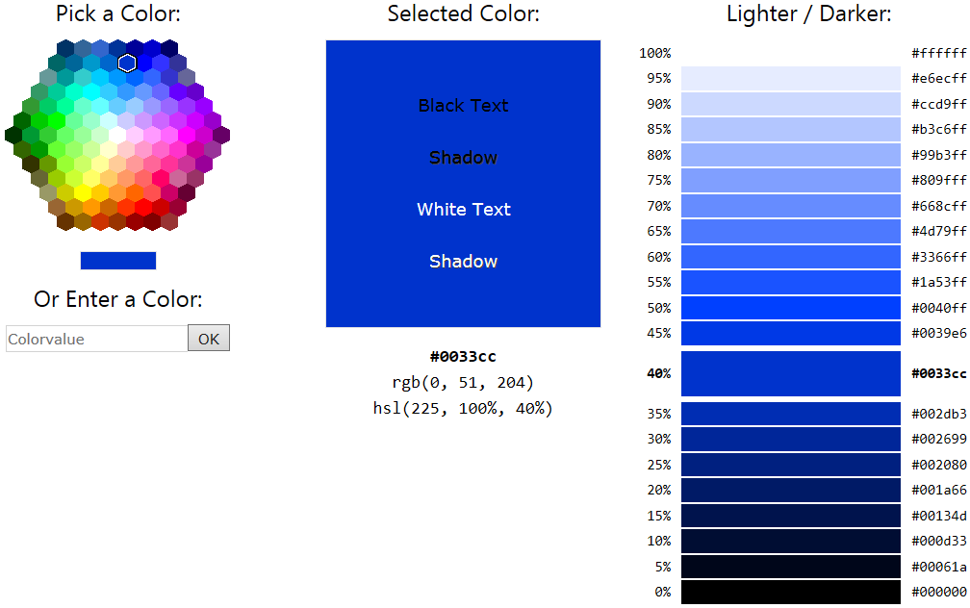

Hue
 | hue | Hex | Rgb | Hsl
 | 0 | #ff0000 | rgb(255, 0, 0) | hsl(0, 100%, 50%)
 | 15 | #ff4000 | rgb(255, 64, 0) | hsl(15, 100%, 50%)
 | 30 | #ff8000 | rgb(255, 128, 0) | hsl(30, 100%, 50%)
 | 45 | #ffbf00 | rgb(255, 191, 0) | hsl(45, 100%, 50%)
 | 60 | #ffff00 | rgb(255, 255, 0) | hsl(60, 100%, 50%)
 | 75 | #bfff00 | rgb(191, 255, 0) | hsl(75, 100%, 50%)
 | 90 | #80ff00 | rgb(128, 255, 0) | hsl(90, 100%, 50%)
 | 105 | #40ff00 | rgb(64, 255, 0) | hsl(105, 100%, 50%)
 | 120 | #00ff00 | rgb(0, 255, 0) | hsl(120, 100%, 50%)
 | 135 | #00ff40 | rgb(0, 255, 64) | hsl(135, 100%, 50%)
 | 150 | #00ff80 | rgb(0, 255, 128) | hsl(150, 100%, 50%)
 | 156 | #00ff99 | rgb(0, 255, 153) | hsl(156, 100%, 50%)
 | 165 | #00ffbf | rgb(0, 255, 191) | hsl(165, 100%, 50%)
 | 180 | #00ffff | rgb(0, 255, 255) | hsl(180, 100%, 50%)
 | 195 | #00bfff | rgb(0, 191, 255) | hsl(195, 100%, 50%)
 | 210 | #0080ff | rgb(0, 128, 255) | hsl(210, 100%, 50%)
 | 225 | #0040ff | rgb(0, 64, 255) | hsl(225, 100%, 50%)
 | 240 | #0000ff | rgb(0, 0, 255) | hsl(240, 100%, 50%)
 | 255 | #4000ff | rgb(64, 0, 255) | hsl(255, 100%, 50%)
 | 270 | #8000ff | rgb(128, 0, 255) | hsl(270, 100%, 50%)
 | 285 | #bf00ff | rgb(191, 0, 255) | hsl(285, 100%, 50%)
 | 300 | #ff00ff | rgb(255, 0, 255) | hsl(300, 100%, 50%)
 | 315 | #ff00bf | rgb(255, 0, 191) | hsl(315, 100%, 50%)
 | 330 | #ff0080 | rgb(255, 0, 128) | hsl(330, 100%, 50%)
 | 345 | #ff0040 | rgb(255, 0, 64) | hsl(345, 100%, 50%)
 | 360 | #ff0000 | rgb(255, 0, 0) | hsl(0, 100%, 50%)

Saturation
 | sat | Hex | Rgb | Hsl
 | 100% | #00ff99 | rgb(0, 255, 153) | hsl(156, 100%, 50%)
 | 95% | #06f998 | rgb(6, 249, 152) | hsl(156, 95%, 50%)
 | 90% | #0df296 | rgb(13, 242, 150) | hsl(156, 90%, 50%)
 | 85% | #13ec95 | rgb(19, 236, 149) | hsl(156, 85%, 50%)
 | 80% | #19e694 | rgb(25, 230, 148) | hsl(156, 80%, 50%)
 | 75% | #20df93 | rgb(32, 223, 147) | hsl(156, 75%, 50%)
 | 70% | #26d991 | rgb(38, 217, 145) | hsl(156, 70%, 50%)
 | 65% | #2dd290 | rgb(45, 210, 144) | hsl(156, 65%, 50%)
 | 60% | #33cc8f | rgb(51, 204, 143) | hsl(156, 60%, 50%)
 | 55% | #39c68e | rgb(57, 198, 142) | hsl(156, 55%, 50%)
 | 50% | #40bf8c | rgb(64, 191, 140) | hsl(156, 50%, 50%)
 | 45% | #46b98b | rgb(70, 185, 139) | hsl(156, 45%, 50%)
 | 40% | #4db38a | rgb(77, 179, 138) | hsl(156, 40%, 50%)
 | 35% | #53ac88 | rgb(83, 172, 136) | hsl(156, 35%, 50%)
 | 30% | #59a687 | rgb(89, 166, 135) | hsl(156, 30%, 50%)
 | 25% | #609f86 | rgb(96, 159, 134) | hsl(156, 25%, 50%)
 | 20% | #669985 | rgb(102, 153, 133) | hsl(156, 20%, 50%)
 | 15% | #6c9383 | rgb(108, 147, 131) | hsl(156, 15%, 50%)
 | 10% | #738c82 | rgb(115, 140, 130) | hsl(156, 10%, 50%)
 | 5% | #798681 | rgb(121, 134, 129) | hsl(156, 5%, 50%)
 | 0% | #808080 | rgb(128, 128, 128) | hsl(156, 0%, 50%)

Lightness
 | light | Hex | Rgb | Hsl
 | 100% | #ffffff | rgb(255, 255, 255) | hsl(156, 100%, 100%)
 | 95% | #e6fff5 | rgb(230, 255, 245) | hsl(156, 100%, 95%)
 | 90% | #ccffeb | rgb(204, 255, 235) | hsl(156, 100%, 90%)
 | 85% | #b3ffe0 | rgb(179, 255, 224) | hsl(156, 100%, 85%)
 | 80% | #99ffd6 | rgb(153, 255, 214) | hsl(156, 100%, 80%)
 | 75% | #80ffcc | rgb(128, 255, 204) | hsl(156, 100%, 75%)
 | 70% | #66ffc2 | rgb(102, 255, 194) | hsl(156, 100%, 70%)
 | 65% | #4dffb8 | rgb(77, 255, 184) | hsl(156, 100%, 65%)
 | 60% | #33ffad | rgb(51, 255, 173) | hsl(156, 100%, 60%)
 | 55% | #1affa3 | rgb(26, 255, 163) | hsl(156, 100%, 55%)
 | 50% | #00ff99 | rgb(0, 255, 153) | hsl(156, 100%, 50%)
 | 45% | #00e68a | rgb(0, 230, 138) | hsl(156, 100%, 45%)
 | 40% | #00cc7a | rgb(0, 204, 122) | hsl(156, 100%, 40%)
 | 35% | #00b36b | rgb(0, 179, 107) | hsl(156, 100%, 35%)
 | 30% | #00995c | rgb(0, 153, 92) | hsl(156, 100%, 30%)
 | 25% | #00804d | rgb(0, 128, 77) | hsl(156, 100%, 25%)
 | 20% | #00663d | rgb(0, 102, 61) | hsl(156, 100%, 20%)
 | 15% | #004d2e | rgb(0, 77, 46) | hsl(156, 100%, 15%)
 | 10% | #00331f | rgb(0, 51, 31) | hsl(156, 100%, 10%)
 | 5% | #001a0f | rgb(0, 26, 15) | hsl(156, 100%, 5%)
 | 0% | #000000 | rgb(0, 0, 0) | hsl(156, 100%, 0%)

RGB (Red, Green, Blue)
Red | Green | Blue
0 | 255 | 153
rgb(0, 255, 153)
#00ff99

HTML Color Mixer
Mix two colors and see the result.
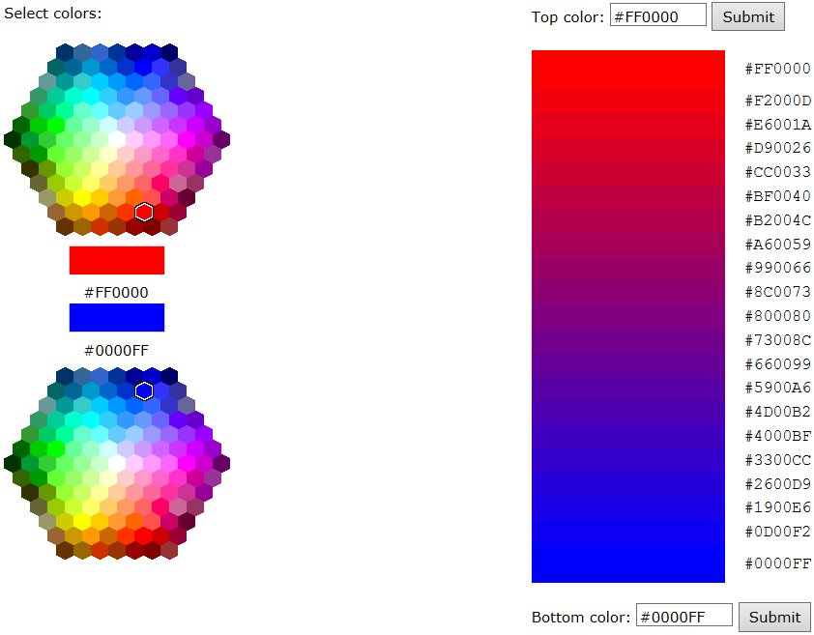

Color Converter
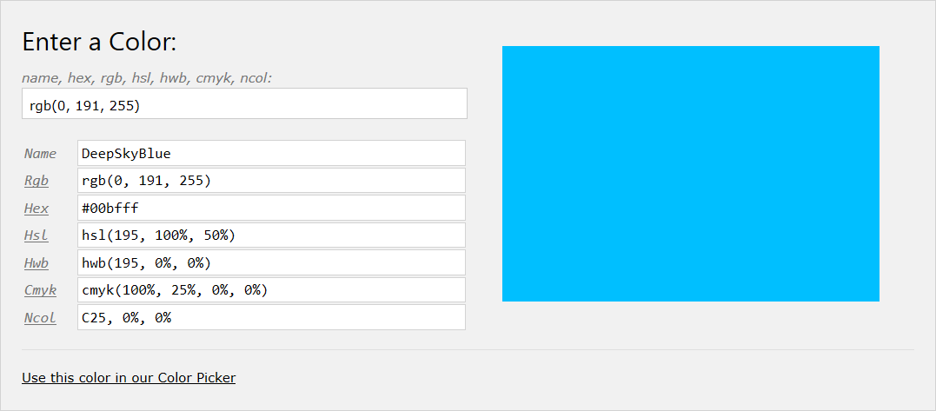
Use this color in our Color Picker

W3Color JavaScript Library
The JavaScript library used in the color converter can be downloaded from
https://www.w3schools.com/lib/w3color.js

Colors RGB
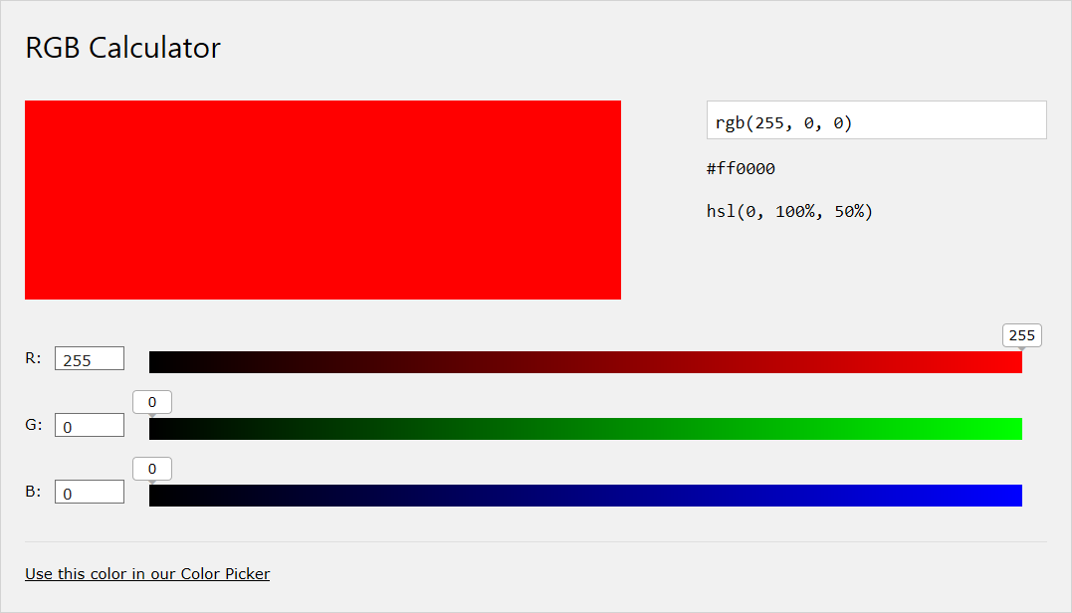
Use this color in our Color Picker

RGB Colors
RGB color values are supported in all browsers.
An RGB color value is specified with: rgb(red, green, blue).
Each parameter (red, green, and blue) defines the intensity of the color as an integer between 0 and 255.
For example, rgb(0, 0, 255) is rendered as blue, because the blue parameter is set to its highest value (255) and the others are set to 0.

Try it Yourself
RGB color values are supported in all major browsers.

Example
<style>
div {
background-color: rgb(0, 191, 255);
color: rgb(255, 255, 255);
}
</style>

Color HEX
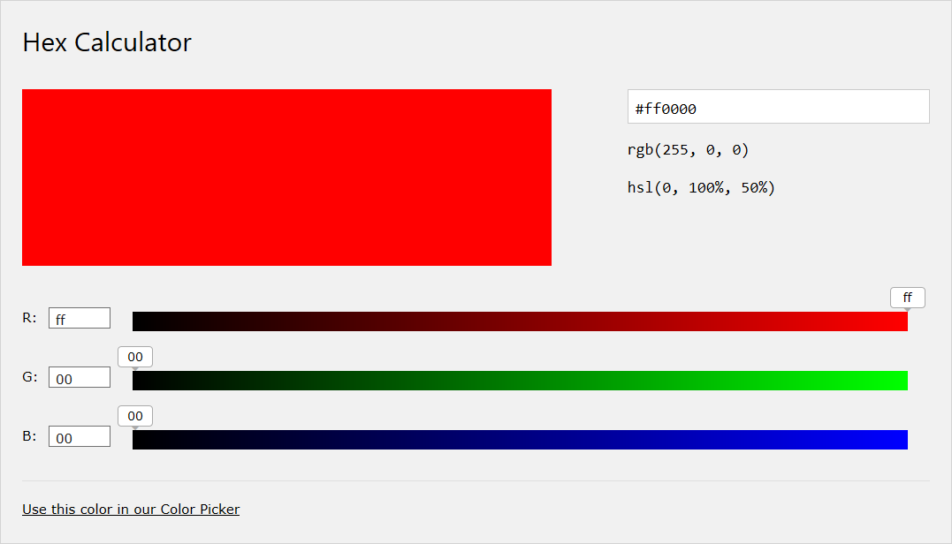
Use this color in our Color Picker

Hexadecimal Colors
Hexadecimal color values are also supported in all browsers.
A hexadecimal color is specified with: #RRGGBB.
RR (red), GG (green) and BB (blue) are hexadecimal integers between 00 and FF specifying the intensity of the color.
For example, #0000FF is displayed as blue, because the blue component is set to its highest value (FF) and the others are set to 00.

Try it Yourself
Hexadecimal color values are supported in all browsers.
<style>
div {
background-color: #00bfff;
color: #ffffff;
}
</style>

Colors HSL
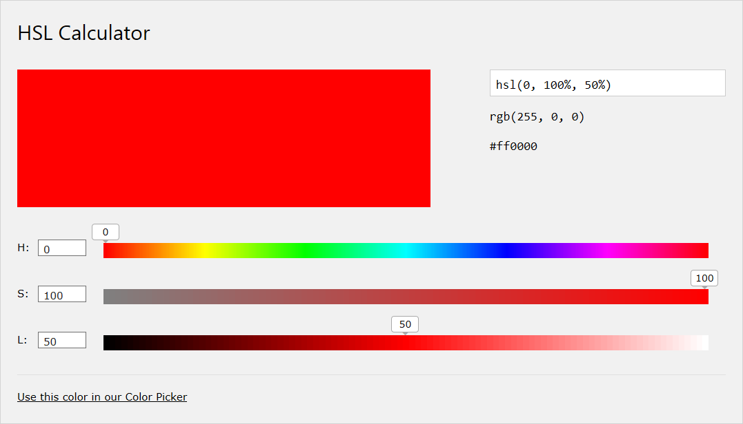
Use this color in our Color Picker

HSL Colors
HSL color values are supported in IE9+, Firefox, Chrome, Safari, and in Opera 10+.
HSL stands for hue, saturation, and lightness.
HSL color values are specified with: hsl(hue, saturation, lightness).

Hue
Hue is a degree on the color wheel from 0 to 360. 0 is red, 120 is green, 240 is blue.

Saturation
Saturation is a percentage value; 0% means a shade of gray and 100% is the full color.

Lightness
Lightness is also a percentage; 0% is black, 100% is white.

Try it Yourself
HSL color values are supported in all major browsers.

Example
<style>
div {
background-color: hsl(180, 50%, 50%);
color: hsl(0, 0%, 100%);
}
</style>

Colors HWB
HWB (Hue, Whiteness, Blackness) is a suggested standard for CSS4.
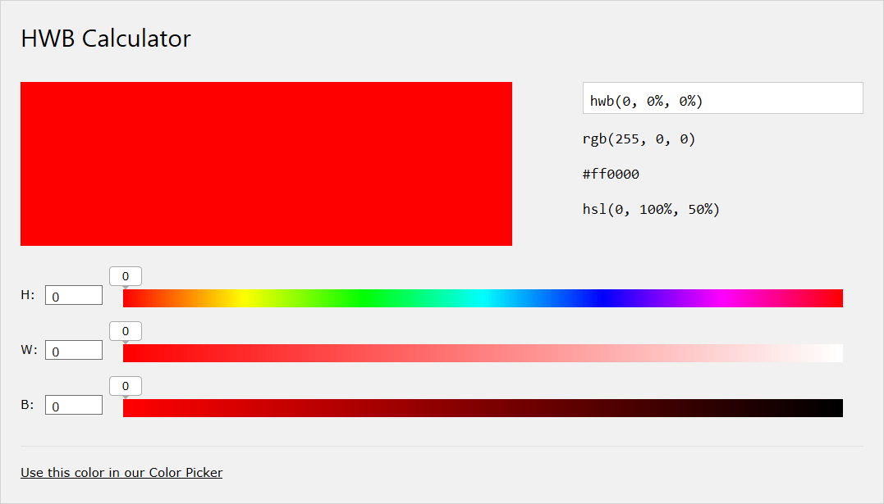
Use this color in our Color Picker

HTML Support
HWB is not supported in HTML (yet), but it is suggested as a new standard in CSS4.
While waiting for CSS4, you can include W3Schools' Color library, and use HWB as an HTML attribute like this:

Example
<div data-w3-color="hwb(60, 50%, 0)">
<p>London is the capital city of England.
It is the most populous city in the United Kingdom,
with a metropolitan area of over 13 million inhabitants.</p>
</div>
<script src="/lib/w3color.js"></script>

W3Schools Color Library
The JavaScript library used in the example above can be downloaded from
https://www.w3schools.com/lib/w3color.js

Colors CMYK
CMYK is a suggested standard for CSS4.
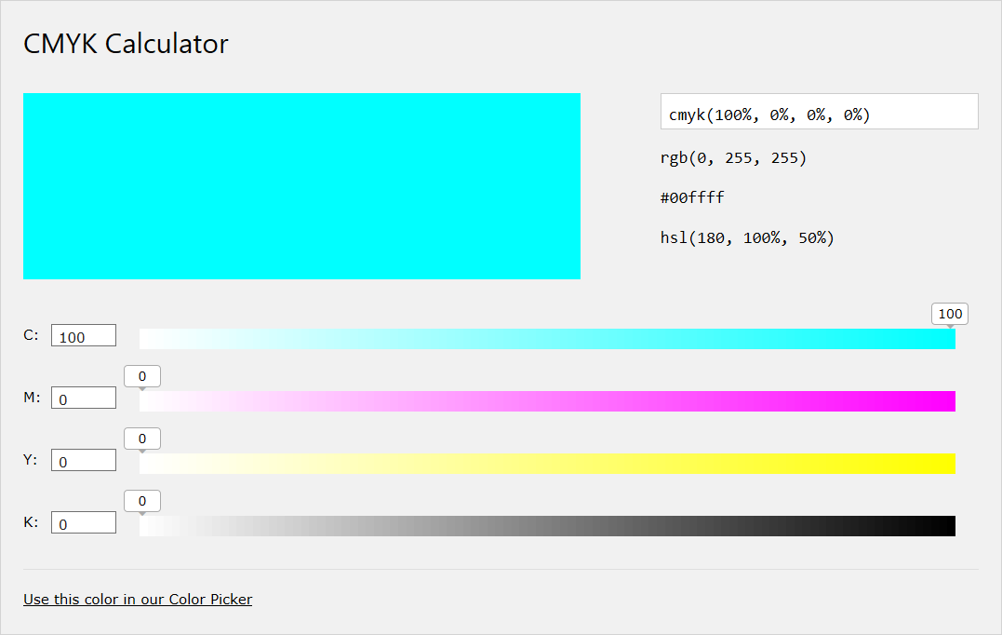
Use this color in our Color Picker

CMYK Colors
CMYK colors is a combination of CYAN, MAGENTA, YELLOW , and BLACK.
Computer screens display colors using RGB color values. Printers often presents colors using CMYK color values.

HTML Support
CMYK is not supported in HTML, but it is suggested as a new standard in CSS4.
While waiting for CSS4, you can include W3Schools' Color library, and use CMYK as an HTML attribute like this:


Try it Yourself

Example
<div data-w3-color="cmyk(100%, 0%, 0%, 0%)">
<p>London is the capital city of England.
It is the most populous city in the United Kingdom,
with a metropolitan area of over 13 million inhabitants.</p>
</div>
<script src="/lib/w3color.js"></script>

W3Schools Color Library
The JavaScript library used in the example above can be downloaded from:
https://www.w3schools.com/lib/w3color.js

Colors NCol
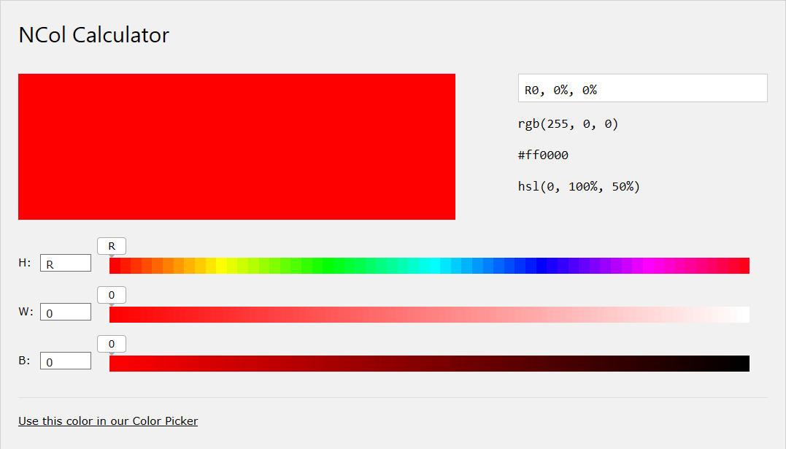
Use this color in our Color Picker

Natural Colors (NCol)
Natural colors (NCol) is an initiative from W3Schools.
The system is designed to make it easier to select HTML colors.
NCol specifies colors using a color letter with a number to specify the distance (in percent) from the color.
R30 means 30% away from Red , moving towards Yellow. (In other words: Red with 30% Yellow)
Letter | Color | Hues
R | Red | R  R25  R50  R75
Y | Yellow | Y  Y25  Y50  Y75
G | Green | G  G25  G50  G75
C | Cyan | C  C25  C50  C75
B | Blue | B  B25  B50  B75
M | Magenta | M  M25  M50  M75

R |  |  |  |  |  |  |  |  |  | Y |  |  |  |  |  |  |  |  |  | G |  |  |  |  |  |  |  |  |  | C |  |  |  |  |  |  |  |  |  | B |  |  |  |  |  |  |  |  |  | M
Color and distance can also be given in hues (0-360):
R = 000 | Y = 060 | G = 120 | C = 180 | B = 240 | M = 300

HTML Support
NCol is not supported in HTML (yet), but it is very close to the new HWB color system suggested in CSS4.
While waiting for CSS4, you can include W3Schools' Color library, and use NCol as an HTML attribute like this:

Example
<div data-w3-color="R50,50%,0">
<p>London is the capital city of England.
It is the most populous city in the United Kingdom,
with a metropolitan area of over 13 million inhabitants.</p>
</div>
<script src="/lib/w3color.js"></script>

W3Schools Color Library
The JavaScript library used in the example above can be downloaded from
https://www.w3schools.com/lib/w3color.js

Why NCol?
Trying to explain colors using RGB or HEX notation is very difficult.
Can you tell what color rgb(199,21,133) is?
RGB is based on how to physically produce colors by mixing light sources.
NCol is based on what colors look like to the human eye.
Because of this, NCol makes it much easier to describe colors.
Natural colors were first described by Karl Ewald Konstantin Hering (Germany 1834 - 1918).
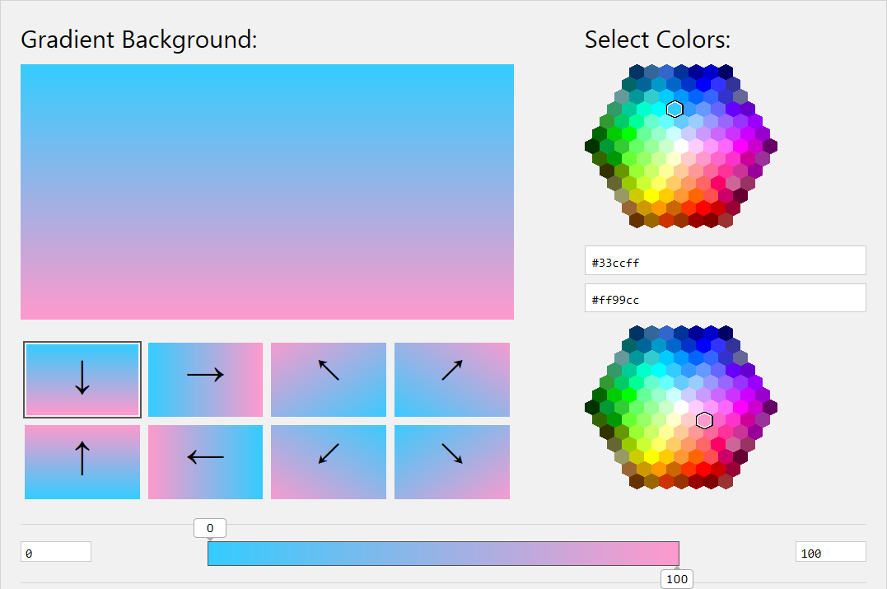

CSS Code:
div {
background: linear-gradient(to bottom, #33ccff 0%, #ff99cc 100%);
}

Color Theory

What is Color Theory?
Color theory is a multitude of categories, definitions and concepts.
This tutorial covers the parts that are most useful for web design:
Primary, Secondary, and Tertiary Colors
Color Wheels (RGB, CMY, RYB)
Color Hue, Lightness and Saturation

The Color of Light
Sir Isaac Newton developed the theory that all colors are mixtures of Red, Green, and Blue light.
This resulted in the first known color circle in 1666.
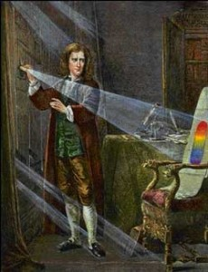 | 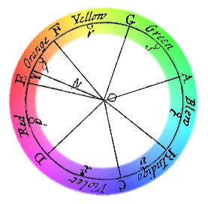

The Color of Paint
In 1766 he scientist Moses Harris created the first color wheel to classify Red, Yellow, and Blue as the primary colors.
Moses Harris worked with paint (Newton worked with light) following a theory (by a French painter) that all colors are mixtures of Red, Yellow, and Blue pigments.
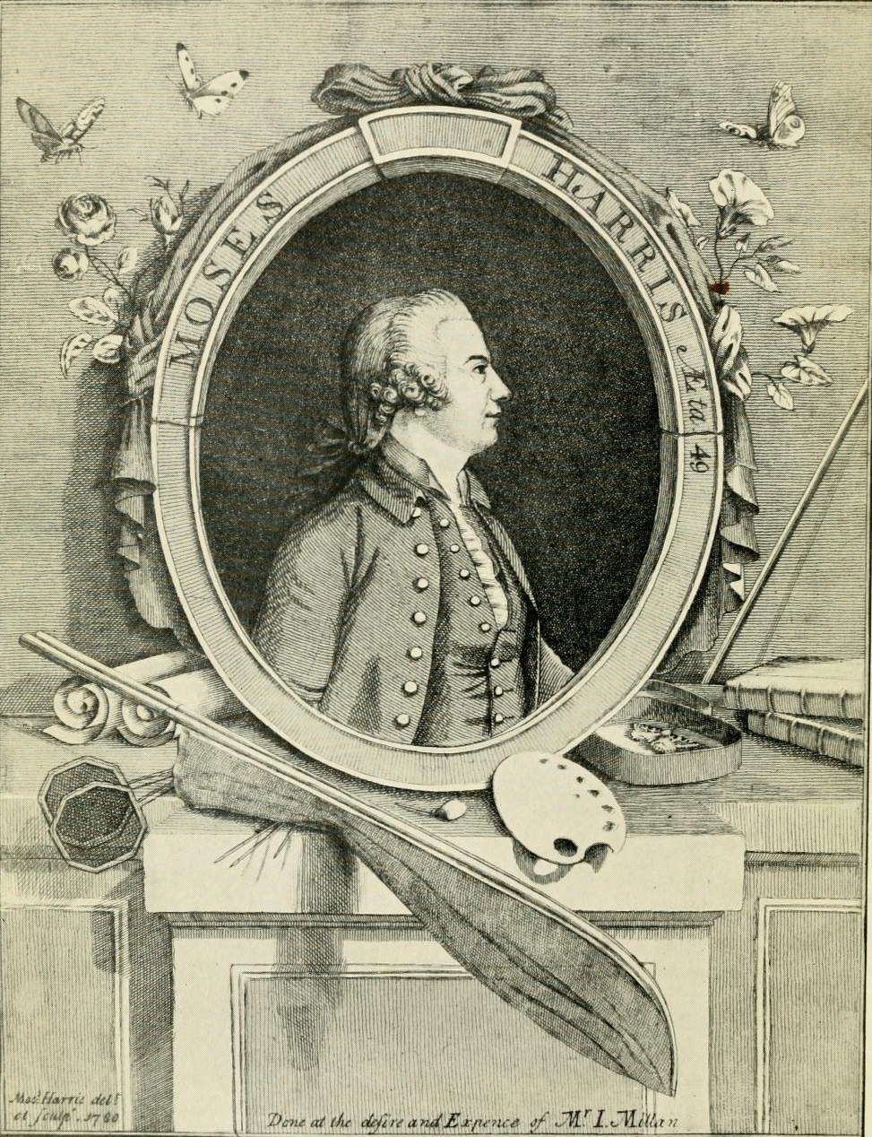 | 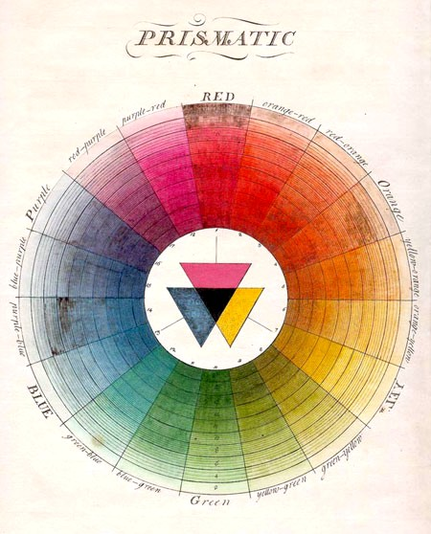

Color Systems
In this tutorial we will cover 3 different color systems:
- The color system used when producing colors by light (RGB)
- The color system used when printing (CMY)
- The color system used by artist and painters (RYB)
Printing actually uses a four ink color system.
CMYK: Cyan, Magenta, Yellow, and Key (black).

Primary Colors
Primary colors are the main colors in a given color system.
Primary colors can not be pruduced by mixing other colors a color system.
The primary colors for light are Red, Green, and Blue:
RGB | Red | Green | Blue
The primary colors for print are Cyan, Magenta, and Yellow:
CMY | Cyan | Magenta | Yellow
The primary colors for paint are Red, Yellow, and Blue:
RYB | Red | Yellow | Blue

Secondary Colors
Secondary colors are made by mixing two primary colors in a color system
There are 3 secondary colors in the color systems described here.

Mixing Light (RGB)
Secondary colors are Yellow, Cyan Magenta.
Red | + | Green | = | Yellow
Green | + | Blue | = | Cyan
Blue | + | Red | = | Magenta

Mixing Ink (CMY)
Secondary colors are Blue, Red, Green.
Cyan | + | Magenta | = | Blue
Magenta | + | Yellow | = | Red
Yellow | + | Cyan | = | Green
Note that mixing the primary colors of CMY produces the primary colors of light (RGB)

Mixing Paint (RYB)
Secondary colors are Orange, Green, Violet.
Red | + | Yellow | = | Orange
Yellow | + | Blue | = | Green
Blue | + | Red | = | Purple

Tertiary Colors
Tertiary colors are made by mixing two secondary colors in a color system.
There are six named tertiary colors in RYB:
- Red-Orange
- Yellow-Orange
- Yellow-Green
- Blue-Green
- Blue-Purple
- Red-Purple

Color Wheels
A color wheel is an illustrative organization of colors around a circle, showing the relationships between primary colors, secondary colors, and tertiary colors.
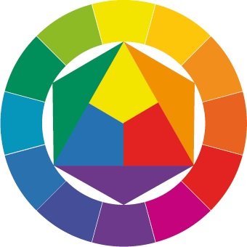

Three Important Color Wheels
How many ways can you rearrange the rainbow?
RGB  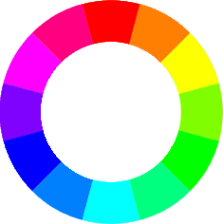  Red, Green, Blue | CMY  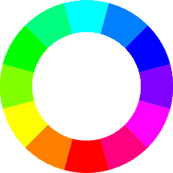  Cyan, Magenta, Yellow | RYB  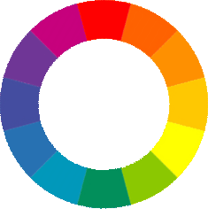  Red, Yellow, Blue

The RGB Color Wheel
The RGB (Red, Green, Blue) color wheel represents the 3 light sources used to produce colors on a TV or computer screen.
Primary colors are Red, Green, and Blue.
Secondary colors are created by mixing primary colors:
Red and Green= Yellow
Green and Blue = Cyan
Blue and Red = Magenta

The 12 Main Colors of RGB:
RED  #FF0000  (255,0,0) | #FF8000  (255,128,0) | YELLOW  #FFFF00  (255,255,0) | #80FF00  (128,255,0) | GREEN  #00FF00  (0,255,0) | #00FF80  (0,255,80)
CYAN  #00FFFF  (0,255,255) | #0080FF  (0,128,255) | BLUE  #0000FF  (0,0,255) | #8000FF  (128,00,255) | MAGENTA  #FF00FF  (255,0,255) | #FF0080  (255,0,128)
RGB Green is different from the HTML color named Green.
RGB Green is different from the HTML color named Green.
Read more about RGB.

The CMY(K) Color Wheel
The CMY(K) (Cyan, Magenta, Yellow) represent the colors used to print on paper.
The primary colors are Cyan, Magenta, and Yellow.
Secondary colors are created by mixing primary colors:
Cyan and Magenta = Blue
Magenta and Yellow = Red
Yellow and Cyan = Green.

The 12 Main Colors of CYM:
CYAN  #00FFFF  (0,255,255) | #0080FF  (0,128,255) | BLUE  #0000FF  (0,0,255) | #8000FF  (128,00,255) | MAGENTA  #FF00FF  (255,0,255) | #FF0080  (255,0,128)
RED  #FF0000  (255,0,0) | #FF8000  (255,128,0) | YELLOW  #FFFF00  (255,255,0) | #80FF00  (128,255,0) | GREEN  #00FF00  (0,255,0) | #00FF80  (0,255,80)
Read more about CMYK.

The RYB Color Wheel
The RYB (Red, Yellow, Blue) color wheel is used by painters, artists and designers for blending pigment colors.
The 3 primary colors are Red, Yellow, and Blue.
Secondary colors are created by mixing primary colors.
The 3 secondary colors are Orange, Green, and Purple.
Red and Yellow = Orange
Yellow and Blue = Green
Blue and Red = Purple.
The tertiary colors are made by mixing two secondary colors.
The 6 tertiary colors are Red-Orange, Yellow-Orange, Yellow-Green, Blue-Green, Blue-Purple, Red-Purple

The 12 Main Colors of RYB:
RED  #FE2712 | R-O  #FC600A | ORANGE  #FB9902 | Y-O  #FCCC1A | YELLOW  #FEFE33 | Y-G  #B2D732
GREEN  #66B032 | B-G  #347C98 | BLUE  #0247FE | B-P  #4424D6 | PURPLE  #8601AF | R-P  #C21460
RYB is the best color wheel to identify the colors that go well together.
The RYB wheel can be used to create pleasing color schemes for the web.
You will learn more about color schemes in the chapter of Color Schemes.

Color Hues, Tints, Shades, and Tones

Color Hue
Hue is just another word for color.
Simply put: Each position around the color wheel represents a different hue:

#ff0000

#ff8000

#ffff00
You can experiment with hue values using our Color Picker.

Color Value (Lightness / Darkness)
Color value is a term for how light or dark dark a color is (from white to black)
These 3 examples changes the lightness and darkness for red, orange, and yellow hues:

#ff0000

#ff8080

#800000

#ff8000

#ffcc99

#663300

#ffff00

#ffff99

#666600
You can experiment with lightness and darkness for the same hue using our Color Picker.

Color Saturation
Saturation is about intensity.
Highly saturated colors are bright. Desaturated colors have less pigment.
These 3 examples changes the saturation for red, orange, and yellow hues:

#ff0000

#cc3333

#996666

#ff8000

#cc8033

#998066

#ffff00

#cccc33

#999966
You can experiment with saturation values for the same hue using our Color Picker.

Color Schemes
Color schemes are logical combinations of colors on the color wheel.
The purpose of a color scheme is to create an aesthetic feeling of style and appeal.

Achromatic Color Schemes
The black on white achromatic color scheme is the default color scheme for a web page:
It uses a white background with a black text.
The white on black achromatic color scheme is often preferred for smaller devices:
It uses a white background with a black text.
White on black requires less energy (improves battery life) on most display technologies.

Monochromatic Color Schemes
Monochromatic color schemes are easy to create because the use only one color.
Monochromatic schemes use different tones from the same angle on the color wheel (the same hue):
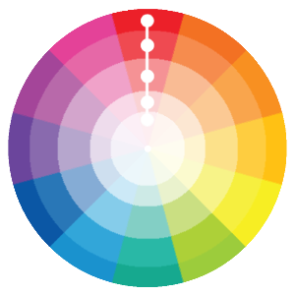
Using different shades and tints from the same hue makes it easy to design good looking color schemes:
#fdf3f3 | #eb8c83 | #dd4132 | #6e1a12 | #420f0b
Hue is another word for color. It is often used in color theory.
#e7fff9 | #afffea | #005e51 | #004f3a | #003829
Monochromatic color schemes are guaranteed to suit each other because they all are from the same family.
You can experiment with lightness, darkness, and saturation values for the same hue using our Color Picker.

Analogous Color Schemes
Analogous color schemes are also easy to create.
Analogous color schemes are created by using colors that are next to each other on the color wheel:
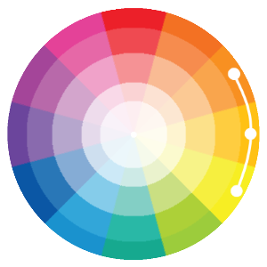
Using only different hues makes it easy to design good looking color schemes:
#6666ff | #66b3ff | #66ffff | #66ffb3 | #66ff8c
If an analogous color scheme does not have enough contrast between the colors (for an nice website design), it can be adjusted to give it more variety:
#b3d9ff | #0066cc | #80bfff | #ccffe6 | #134d00
You can experiment with lightness, darkness, and saturation adjustment using our Color Picker.

Complementary
Complementary schemes are created by combining colors from opposite sides of the color wheel:
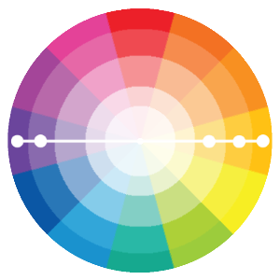
Most of these schemes consist of two complementary colors expanded with grey tones, tints, and shades.
This scheme consists of complementary red and green:
#c2c2b2 | #ff666a | #ff0f15 | #0bb238 | #9affb5
This scheme consists of complementary orange and blue:
#b2c2c2 | #ffdaa1 | #ffa111 | #0c69b2 | #7bc5ff
To avoid simple complementary color schemes add lightness, darkness, or saturation:
#e2e9e9 | #ffebcc | #ffb84d | #40a5f2 | #cce9ff

#7e9a9a | #f6d8ac | #db9833 | #2a6592 | #8ec3eb
You can experiment with lightness, darkness, and saturation values using our Color Picker.

Compound (aka Split Complementary)
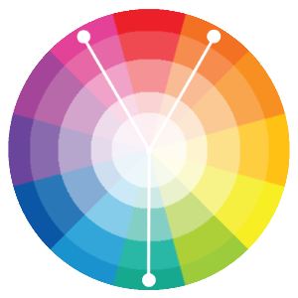
Compound schemes are almost the same as complementary schemes.
Instead of using colors that are opposites, it uses colors on both sides of the opposite hue:
#cc5520 | #997463 | #ff4441 | #81ff85 | #55cc20

Triadic
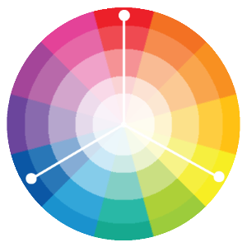
Triadic schemes are made up of hues equally spaced around color wheel:
#b2312f | #ff5f5c | #ffff77 | #7aaacc | #3c81b2
A very dark or very pale version of one color in the triad, can make this single color stand out in the scheme:
#5eccc0 | #11b2a2 | #ffd736 | #b200a4 | #ff6df3

#5eccc0 | #11b2a2 | #ffeb99 | #b200a4 | #ff6df3

#5eccc0 | #11b2a2 | #806600 | #b200a4 | #ff6df3

Color Palettes
On this page you will find some carefully designed color palettes, free to use.
ON TOUR
2017
FREE
101
TEMPLATES
101
COLOR
PALETTES
LOTS OF
NEW
INSPIRATION

2017 Palettes
HEX: #d6cbd3  HEX: #eca1a6  HEX: #bdcebe  HEX: #ada397 | HEX: #d5e1df  HEX: #e3eaa7  HEX: #b5e7a0  HEX: #86af49
HEX: #b9936c  HEX: #dac292  HEX: #e6e2d3  HEX: #c4b7a6 | HEX: #3e4444  HEX: #82b74b  HEX: #405d27  HEX: #c1946a

2016 Palettes
HEX: #92a8d1  HEX: #034f84  HEX: #f7cac9  HEX: #f7786b | HEX: #deeaee  HEX: #b1cbbb  HEX: #eea29a  HEX: #c94c4c
HEX: #d5f4e6  HEX: #80ced6  HEX: #fefbd8  HEX: #618685 | HEX: #ffef96  HEX: #50394c  HEX: #b2b2b2  HEX: #f4e1d2
HEX: #fefbd8  HEX: #618685  HEX: #36486b  HEX: #4040a1 | HEX: #b2b2b2  HEX: #f4e1d2  HEX: #f18973  HEX: #bc5a45

2015 Palettes
HEX: #f0f0f0  HEX: #c5d5c5  HEX: #9fa9a3  HEX: #e3e0cc | HEX: #eaece5  HEX: #b2c2bf  HEX: #c0ded9  HEX: #3b3a30
HEX: #e4d1d1  HEX: #b9b0b0  HEX: #d9ecd0  HEX: #77a8a8 | HEX: #f0efef  HEX: #ddeedd  HEX: #c2d4dd  HEX: #b0aac0

Rustic Palettes
HEX: #c8c3cc  HEX: #563f46  HEX: #8ca3a3  HEX: #484f4f | HEX: #e0e2e4  HEX: #c6bcb6  HEX: #96897f  HEX: #625750
HEX: #7e4a35  HEX: #cab577  HEX: #dbceb0  HEX: #838060 | HEX: #bbab9b  HEX: #8b6f47  HEX: #d4ac6e  HEX: #4f3222
HEX: #686256  HEX: #c1502e  HEX: #587e76  HEX: #a96e5b | HEX: #454140  HEX: #bd5734  HEX: #a79e84  HEX: #7a3b2e

Sky Palettes
HEX: #bccad6  HEX: #8d9db6  HEX: #667292  HEX: #f1e3dd | HEX: #cfe0e8  HEX: #b7d7e8  HEX: #87bdd8  HEX: #daebe8

Sand Palettes
HEX: #fbefcc  HEX: #f9ccac  HEX: #f4a688  HEX: #e0876a | HEX: #fff2df  HEX: #d9ad7c  HEX: #a2836e  HEX: #674d3c

Flower Palettes
HEX: #f9d5e5  HEX: #eeac99  HEX: #e06377  HEX: #c83349 | HEX: #5b9aa0  HEX: #d6d4e0  HEX: #b8a9c9  HEX: #622569

Beach Palettes
HEX: #96ceb4  HEX: #ffeead  HEX: #ffcc5c  HEX: #ff6f69 | HEX: #588c7e  HEX: #f2e394  HEX: #f2ae72  HEX: #d96459

Color Brands

Hex values intended to simulate approximately branded colors.

Google

HEX: #4285F4
HEX: #FBBC05
HEX: #34A853
HEX: #EA4335

Twitter

HEX: #55ACEE
HEX: #292F33
HEX: #66757F
HEX: #CCD6DD
HEX: #E1E8ED
HEX: #FFFFFF

Facebook

HEX: #3B5998
HEX: #8B9DC3
HEX: #DFE3EE
HEX: #F7F7F7
HEX: #FFFFFF

Microsoft

HEX: #F65314
HEX: #7CBB00
HEX: #00A1F1
HEX: #FFBB00

Intel:
HEX: #0F7DC2

Instagram:
HEX: #3F729B

IBM
HEX: #006699

Yahoo!
HEX: #7B0099

Amazon
HEX: #FF9900
HEX: #146EB4

Netflix
HEX: #221F1F
HEX: #E50914

Coca-Cola
HEX: #ED1C16

Pepsi
HEX: #E32934
HEX: #004883

IKEA
HEX: #FFCC00
HEX: #003399

Android
HEX: #A4C639

Color Trends

Color of the Year 2017

Greenery
HEX: #92B558
Pantone 15-0343
Every year the Pantone Color Institute (known to define Colors of the Year) evaluates the colors shown by fashion designers at the New York Fashion Week.
This information is used to create The Pantone Color of the Year and the Pantone Fashion Color Report with the top 10 fashion colors for the comming season:
The HEX values are non official approximate values intended to simulate the colors in HTML.

The Hottest Fall Colors for 2017

Grenadine
HEX: #DC4C46
Pantone 17-1558

Tawny Port
HEX: #672E3B
Pantone 19-1725

Ballet Slipper
HEX: #F3D6E4
Pantone 13-2808

Butterum
HEX: #C48F65
Pantone 16-1341

Navy Peony
HEX: #223A5E
Pantone 19-4029

Neutral Gray
HEX: #898E8C
Pantone 17-4402

Shaded Spruce
HEX: #005960
Pantone 19-4524

Golden Lime
HEX: #9C9A40
Pantone 16-0543

Marina
HEX: #4F84C4
Pantone 17-4041

Autumn Maple
HEX: #D2691E
Pantone 17-1145

